FREQUENTLY ASKED QUESTIONS
GENERAL QUERIES OF THE SHAREHOLDERS
ARE ANSWERED HERE
(last updated on 13-07-2026)

I am having shares of Jasch Industries Ltd in physical form. How can I dematerialize these shares?

Under a Scheme of Arrangement which was approved by the Hon’ble National Company Law Tribunal, Jasch Industries Ltd has been demerged into two entities – Jasch Industries Ltd and Jasch Gauging Technologies Ltd. All physical share certificates of Jasch Industries Ltd have been cancelled, and shares comprised therein have been automatically dematerialized. These dematerialized shares are currently held in two separate Demat Escrow Accounts in the ratio of 60:40 maintained by Jasch Industries Ltd and Jasch Gauging Technologies Ltd respectively and you can claim the shares from these escrow accounts after opening a demat account. After you follow the procedure given elsewhere under FAQs, these shares will be credited to your demat account. In respect of physical shares, in case dividend has remained unpaid for seven consecutive years, the same has been transferred to IEPF (also split in the ratio of 60 : 40 with IEPF).

Therefore, If you are still holding share certificates in physical form, it is indicative either of the following two things:

Your shares have been transferred to IEPF because the dividend in respect of the shares has remained unpaid for seven consecutive years. You may write to the company/RTA to ascertain whether these shares have been transferred to IEPF. Procedure to claim the same from IEPF is given elsewhere in these FAQs

or

(b) In case the above is not applicable to your case, then the share certificates have been automatically dematerialised under a Scheme of Demerger and transferred to demat escrow accounts. The company holds these dematerialised shares as your trustee and you can claim the same from the company after opening a demat account. Procedure to claim the same from demat escrow account is given elsewhere in these FAQs.

How can I claim the shares/unclaimed dividend transferred to IEPF Authority?

The shareholder or the legal heir needs to submit two separate applications to IEPF – one for Jasch Industries Ltd and the other for Jasch Gauging Technologies Ltd, to claim shares in the ratio of 60:40 respectively. Online applications in Web-Form IEPF-5 available on IEPF website www.iepf.gov.in. Application can also be made by any successor, legal heir / representative of the deceased person. Latest Complete procedure is given under the following weblink:

Please click here for latest "Help & FAQs" of IEPF

What documents are required to be submitted with IEPF claim?

Claimants after making an application in Web-Form IEPF-5 have to send self certified copies of the following documents to the Nodal Officer of the Company for verification of the claim.

  - Form IEPF-5 along with challan generated by the system
  - Advance receipt generated by the system
  - Indemnity bond (on non-judicial stamp paper of Rs. 100)
  - Aadhaar Card
  - Pan Card
  - Client Master List of Demat A/c
    - Proof of entitlement (Original share certificate if available. If not available, then you have to get an “Entitlement Letter” from Alankit¹ and use instead of the share certificate – see procedure below). In case of claim of shares of Jasch Gauging Technologies Ltd, please attach therewith a copy of share certificate of Jasch Industries Ltd instead, since physical shares of Jasch Gauging Technologies Ltd do not exist).
  - Original cancelled cheque leaf
    - Even if there is a slight mismatch between the name and/or address as per Aadhaar Card and Company’s records, an affidavit to this effect is also required to be provided.
Notes:
- All the pages of all the documents to be submitted by you should be self-attested by the claimant and joint holder, if any.
- Even for minor change in name, an affidavit is required and for major change in name, a gazette notification is required. Your address in demat account will automatically be your new address.
- After filing IEPF-5 form, please send all the aforementioned documents to the Nodal Officer of the respective company positively within the net seven days. The Company is required to complete the verification process in a time-bound manner (time is counted from the day when you file IEPF-5 on-line), after which liability to pay per-day penalty arises.
- My relative, who was holding shares in physical form, has expired. How can I transfer these shares in my name ?
First of all, you need to obtain a Succession Certificate from a court of competent jurisdiction, declaring that you are the legal heir of the assets of the deceased. Thereafter, you should open a demat account in your own name and follow the procedure given under Sr. No. 1 above. Please also read the information under the following tab :
Procedure for transmission of shares on demise of a shareholder

- What are the contact details of Jasch Gauging Technologies Ltd?

Website address of JGTL is www.jasch.net.in. “Investors” Section thereof contains information which may be relevant to the shareholders of JGTL. Address of the Nodal Officer is: Shri Neeraj Kumar, Nodal Officer - IEPF, Jasch Gauging Technologies Ltd, 43/2, Bahalgarh Road, Sonipat 131021 (email cs@jasch.biz)

I am having shares in demat form, how do I change my address, email id and bank details?

For any change (name, address, email, etc) in your demat account, please contact your Depository Participant (the entity with which you have demat account) as the company has no role in the matter. Whatever information you provide to your DP, will automatically be fetched by us.

How do I apply for duplicate share certificate/Entitlement Letter in case of loss of share certificate?

Physical duplicate share certificates are not being issued any longer. In case you have lost your physical share certificate, then you need to send a request letter in form ISR-4 to Alankit duly signed by the holder along with FIR copy, self-attested ID Proof, Address proof, Indemnity bond & Affidavit in separate 100 Rs non judicial stamp paper. After satisfying itself that you are the actual holder of the share certificates, then Instead of issuing a duplicate share certificate, Alankit will issue an “Entitlement Letter”, which you can use as a share certificate for the limited purpose of claiming shares from IEPF.

Form ISR-4 and draft affidavit for issue of Entitlement Letter is given at the end of this FAQs:

- What is “Demat”.
“Demat” is the short form for “Dematerialisation”. It is a process under which physical share certificates are cancelled and a credit entry is made in the shareholder’s demat account for the shares held by him in different companies. In other words, it is a paperless form of a share certificate.

- How do I open a demat account?

Demat accounts are opened by the entities known as “Depository Participants (“DPs”)” at the request of shareholders. To see a list of DPs in your area, visit the following link : NSDL or CDSL | DPs (cdslindia.com) (Please note that these are external links over which Jasch Industries Ltd has no control)]. You can open a demat account with any DP of your choice. To open a demat account, kindly follow the following procedure:
Step 1: Visit your preferred DP personally or its website. Keep your Aadhar Card, PAN Card and cancelled cheque ready.
Step 2: Click on the 'Open a Demat and trading account' link on their website.
Step 3: Fill in the application form.
Step 4: Upload scanned copies of all the necessary documents for “Know Your Customer (KYC)” updation.
Step 5: Sign the agreement with the DP along with the charges. This agreement contains the duties and responsibilities of both the depository participant and the account holder. Therefore, it is important to read them thoroughly before putting your signature.
Step 6: Once all the relevant documents are submitted, your application will be processed by the DP.
Step 7: On successful approval of your Demat and trading account application, you will receive a unique user ID and password to access your trading account along with a Demat account number.

- How to claim shares from “Demat Escrow Account”?

(1) Open a demat account. (2) Fill and sign form ISR-4 and affidavit separately for both JIL and JGTL and send the same to the respective Company along with a covering letter and (3) self-certified copy of your client master (document giving details of your demat account) (4) original share certificate [if the original share certificate has been lost, an affidavit to that effect. Form ISR-4 and specimen of affidavit are given at the end of FAQs.

- What procedure is followed by the IEPF/the Company/Alankit for settling the claim?

The Company will verify the accuracy and completeness of the claim and submit a Verification Report to IEPF Authority along with documents received from the claimant.
Based on Verification Report submitted by the Company, IEPF Authority, would:
- Approve the claim,
- Ask the shareholder to resubmit the required documents in case of any discrepancy.
In case IEPF Authority requests the claimant to resubmit any documents, claimant
is to forward the required documents to the Nodal Officer. On receipt of the revised documents from the shareholder, Nodal Officer would forward the revised Verification Report to IEPF Authority for settlement of the claim of the shareholder
Please note that in case of non-receipt of documents by the Authority after the expiry of ninety days from the date of filing of Form IEPF-5, the Authority may reject Form IEPF-5, after giving an opportunity to the claimant to furnish response within a period of thirty days. The Authority shall, if the claim is approved: a. Credit the Dividend amount to the claimants' Aadhaar linked bank account through electronic transfer and b. In case of request for credit of shares, credit the shares to the claimant’s Demat account.

Note: While we are eager that you get back your shares and unpaid dividend from the government (IEPF) soonest, but these are in the custody of IEPF and the Company has no role in the matter, except verifying your claim. IEPF takes it own time to settle the claim and sending reminders to us, will not serve any purpose.

- How fractional shares have been disposed of?

A. All the fractional shares arising out of the split (in the ratio of 3:2) as a result of demerger were consolidated and allotted to an independent Trustee who has sold the same in the open market at best price available. The proceeds of the same (JIL and JGTL shares are being remitted to the bank accounts of the respective shareholders.

Example: A shareholder held 21 shares of JIL prior to 06th October 2023. The same have been cancelled and his/her demat account has been credited with 12 shares of JIL and 8 shares of JGT. Fraction arising out of the remaining 1 share (i.e. fraction of 0.6 share of JIL and 0.4 share of JGTL) were transferred to an independent Trustee who has consolidated all such fractions and sold the same in the open market and proceeds of the same are being credited to the bank account of the shareholder.

- What will be the cost of acquisition of JIL and JGTL shares for the purpose of calculating capital gain under Income Tax Act ?

Please refer to “Apportionment of Cost of Acquisition of shares” under Notices Section.

What are the contact details of Alankit and IEPF?

Alankit Assignments Ltd (Unit: Jasch Industries Limited) 4E/2, Jhandewalan Extension, New Delhi - 110055  Tel: +91-011-42541234, 23541234  E-mail: ramap@alankit.com | Investor Education and Protection Fund  E-mail: iepf@mca.gov.in  Call: 1800 114 667 / Public Relations Officers Phone No: 011-23441777 Helpdesk - 0124-4832500

Important weblinks:

IEPF Website: https://www.iepf.gov.in/
Web-Form IEPF-5 and instruction kit: Ministry of Corporate Affairs (iepf.gov.in)
Company website : www.jaschindustries.com

- How is the Company doing? What are the future plans of the Company?

The annual report, the quarterly financial statements and all the important information about the Company are uploaded at the website of the Company and that of BSE from time to time. These documents amply depict the latest status and financial health of the Company. We appreciate your desire to have “inside” knowledge about the affairs and future plans of the Company. The Company is also eager to share all important information with the investors. However, the Company has a policy of not sharing any information with anyone on individual basis. All the information which may be of interest to shareholders and/or general public is promptly uploaded at the website of the Company and also that of BSE, for the information of all. It is left to the wisdom of the investors/public to draw their own conclusion therefrom. All requests, suggestions or discussions aimed at helping anyone to draw any conclusions from the information disseminated by the Company, are always politely declined.

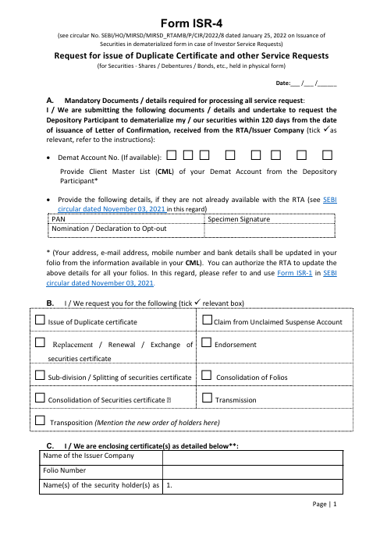

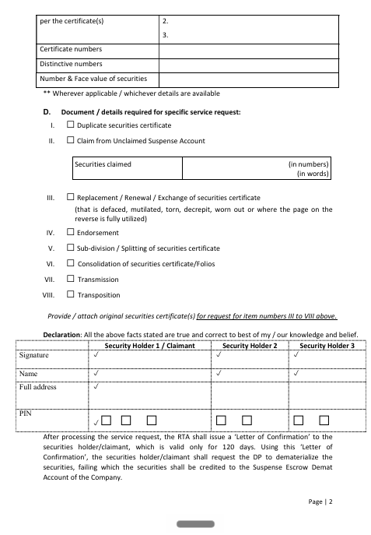

(You may also download a blank form ISR-4 from the internet ).

FORM OF AFFIDAVIT

I s/o resident of do solemnly affirm and declare as under:

That I am a shareholder of Jasch Industries Ltd holding shares in physical form. My folio No. is
, share certificate No. is Distinctive numbers are .

That I am aware that under a Scheme of Arrangement which has been approved by the National Company Law Board vide its order dated 12-09-2023, all physical share certificates (including the above) have been cancelled and the shares have been credited to the Demat Escrow Account of Jasch Industries Ltd and Jasch Gauging Technologies Ltd in the ratio of 6:4 respectively.

That I further understand that after opening a demat account, I can claim the same from the Company in demat mode.

That one of the requirements for claiming the above shares from the Demat Escrow Account is that I have to surrender the original share certificate to the Jasch Industries Ltd. However, the original share certificate held by me has been lost and is not traceable.

That I have neither sold/pledged/traded in the above shares nor will sell/pledge or trade in the above share certificate and return the same to Jasch Industries Ltd, if the share certificate is subsequently found.

That I have requested the above companies to rely on this affidavit and transfer my entitlement of the above shares to my demat account by accepting this affidavit in lieu of the lost share certificate.

Deponent

Verification

I, the aforenamed deponent to hereby verify that the contents of this affidavit are true to the best of my knowledge and that nothing has been concealed therein.

Note (it does not form part of affidavit)
1Alankit (Alankit Assignments) Ltd are Registrars & Share Transfer Agents of the Company, whose complete address is given above. They are a SEBI-registered entity and the Company has delegated to them all the work relating to investor services.

